

Acta Astronautica 234 (2025) 59–72
Contents lists available at ScienceDirect

Acta Astronautica

journal homepage: www.elsevier.com/locate/actaastro

A modified Prandtl’s model for predicting the bearing capacity of lunar soil  ground under extraterrestrial gravitational environment
Banglu Xi ª, Mingjing Jiang ^{b,*}, Lin Qi ª, Jiaqiang Yang ª, Mingliang Chen ª
ª Collage of Civil Engineering, Hefei University of Technology, Hefei, 230009, China
^{b} School of Civil Engineering, Suzhou University of Science and Technology, Suzhou, Jiangsu, 2150092, China

A R T I C L E I N F O

Keywords:
Lunar base Lunar regolith Bearing capacity Gravity effect
Distinct element method
A B S T R A C T

The prediction on bearing capacity of regolith on the Moon plays an important role in the design and con-struction of the future lunar base. However, the classical analytical methods are developed on Earth for terrestrial soils, which may be unable to predict the bearing capacity of lunar soil on the Moon since the gravity effect on the bearing behavior is excluded. Therefore, the assumptions in Prandtl’s bearing capacity theory were
first examined and the gravity effect on such assumptions was detailedly analyzed based on DEM simulations of
plate loading tests under different gravity fields. Then a modified Prandtl’s model considering the gravity effect was developed and verified with the experimental data under different gravity fields. The results showed that the modified Prandtl’s model predicts bearing capacities within 50 % error of experimental data under different gravity fields, which implies that the modified Prandtl’s model can well capture the gravity effect on the bearing capacity of lunar soil and its simulants.

Introduction

The setup of permanent research stations or habitations on the other planets of the solar system is an old dream of mankind. The Moon is the first goal to realize such a mission because of its relative closeness to Earth [1], and Mars is the most anticipated planet because of its similar environment to Earth [2]. For this aim, various lunar habitation designs
have been proposed in the past several decades [3–5], even before the Apollo era [6], including the inflatable structure [7–9], concrete struc-ture [10–13], deployable structure [14,15] and lava tubes [16,17]. In addition to the structure design, the foundation system should also be
carefully designed so that the structure loads can be transferred safely to the lunar soil, which requires a detailed understanding and accurate prediction of the bearing behavior of lunar soil ground on the Moon.
Most lunar habitations are designed to lay on the lunar surface, where the foundation can be regarded as a shallow foundation. Shallow foundation-bearing capacity has been a key focus in geotechnical engi-neering for over a century [18,19]. For example, the famous Prandtl’s
theory was first proposed in 1921 to calculate the bearing capacity of
soils beneath a perfectly smooth plate. After which the widely-employed Terzaghi’s theory was proposed in 1943 for a perfectly rough foundation [18]. Then Meyerhof [20] presented a theoretical method for estimating
the effect of plate roughness. However, the classical analytical methods are developed on Earth under a gravity field of 9.8 m/s² for terrestrial soils, which may be unable to predict the bearing capacity of lunar soil on the Moon with a low gravity of 1.63 m/s² since the gravity effect on the bearing behavior remains excluded [21,22].
In recent decades, great efforts have been made to investigate the gravity effect on the bearing capacity of lunar soil and its simulant through experimental tests [23–25] and numerical simulations [26,27].
For example, Kobayashi et al. [23] performed plate loading tests in a
flying aircraft where different gravity fields (i.e., 0g–2.2 g) could be obtained by parabolic flight path. They found that the bearing behavior of the FJS-1 simulant is hardly influenced by the low gravity level, while
the Toyoura sand exhibits a high dependency on gravity. Perko and Nelson [24] performed plate loading tests in a 6m-height drop tower, and the results showed that the bearing capacity of loose quartz sand
ground decreases significantly with the decreasing gravity level (i.e., 0.14g–1.0 g). Besides, the centrifuge model tests were employed to investigate the mega-gravity effect on the bearing behavior of lunar soil
ground. Lee et al. [28] performed plate loading tests in a large gravity range (i.e., 1–60 g) by centrifuge model test. The results showed that the bearing capacity was proportional to the logarithm of the gravity field.
Perkin and Madson [29] showed that the bearing capacity of MLS-1 and

* Corresponding author.
E-mail address: mingjing.jiang@usts.edu.cn (M. Jiang).

https://doi.org/10.1016/j.actaastro.2025.04.054
Received 2 January 2025; Received in revised form 18 March 2025; Accepted 23 April 2025
Available online 24 April 2025
0094-5765/© 2025 IAA. Published by Elsevier Ltd. All rights are reserved, including those for text and data mining, AI training, and similar technologies.

JSC-1 lunar simulant grounds increases significantly with the gravity field in a range of 1–50 g. In terms of the numerical simulation, Bui et al.
[26] studied the gravity effect on the bearing capacity of lunar simulant
and Toyoura sand by DEM analyses. The results showed that gravity affects the bearing capacity of Toyoura sand while such gravity effect becomes insignificantly on lunar simulant. Xi et al. [27] studied the bearing behavior and soil responses of lunar soil under extraterrestrial environmental effects by performing DEM simulations of plate loading
tests. The results showed that the high-gravity effect in a centrifuge

considering the surcharger pressure q₀ = γ₀d due to the soils above the base bottom (Fig. 2), where γ₀ and d are the weight and depth of the overburden soil [31]. Note that there are two more assumptions in the formula derivation, i.e., the active and passive Rankine earth pressures (i.e., P_{a} and P_{p}) are assumed to act on surfaces OC and BD respectively, as shown in Fig. 2. Therefore, the ultimate bearing capacity P_{u} can be obtained by the limit equilibrium method as follows:
P = qN + cN
u
q
c

cannot be directly applied to predict the bearing behavior of lunar soil

ground in a low-gravity field. It is worth mentioning that the bearing
capacities predicted by conventional theories are always in proportion to gravity levels for shallow foundations lying on cohesion-less soils, which is different from the existing experimental and numerical results. Therefore, it is quite essential to introduce the gravity effect into the classical bearing capacity theories in a complete way to predict the bearing capacity of soils under different gravity fields, which constitutes the strong motivation of this paper.
Attempts have been made to incorporate the gravity effect into conventional bearing capacity theories for predicting the bearing ca-pacity of soils under different gravity fields. Perkin [30] stated that conventional theories can provide adequate predictions by introducing the dependence of the stress parameters on stress. However, it seems unreasonable to simply attribute the gravity effect to the stress depen-dence of stress parameters. Kobayashi et al. [23] proposed a modified upper bound method by incorporating the failure boundary surface, which forms an angle of β from the ground surface. However, such a method may be impractical because the method of estimating β has not yet been proposed.
Therefore, this paper develops a modified Prandtl’s model consid-
ering the gravity effect with strong evidence, aiming to provide a method for calculating the bearing capacity of soils under extraterres-trial gravitational environments. After a brief introduction to Prandtl’s
theory, the assumptions in Prandtl’s theory were examined and the
gravity effect on such assumptions was analyzed in detail based on previous DEM simulations of plate loading tests under different gravity fields [27]. Then these examinations were introduced to modify Prandtl’s theory by adjusting the inappropriate assumptions available
and introducing the gravity effect. Finally, the modified Prandtl’s model
was verified by comparing the predicted values with previous experi-mental data under different gravity levels.

Prandtl’s bearing capacity model

In Prandtl’s bearing capacity model, a triangular wedge followed by a log spiral and tangent (i.e., r = r₀e^{ψtanφ}) was employed for a rigid strip
footing [31], as shown in Fig. 1. When the applied load equals the ul-timate blearing capacity P_{u}, the soils below the plate can be divided to Rankine active zone (Zone I), Rankine passive zone (Zone III) and transition zone (Zone II). The boundaries of the Rankine active and passive zones (i.e., AC and AD) are inclined horizontally at angles of π/4
+ φ/2 and π/4-φ/2, respectively. There are two assumptions in Prandtl’s
model: 1) the soil is weightless; 2) the plate is perfectly smooth. Therefore, the ultimate bearing capacity P_{u} can be obtained using plasticity theory. In 1924, Reissner deduced a modified solution
N = tan²(45 + φ)e^{π} ^{tan} ^{φ}, N = N — 1)cotφ (1)

where N_{c}, N_{q}, N_{γ} are the coefficients of bearing capacity, φ is the internal friction angle and c is the apparent cohesion. Prandtl’s bearing capacity
q
2
c
q
model remains a cornerstone of geotechnical engineering, although its direct application is restricted to idealized scenarios due to those as-sumptions. Contemporary practice in earth constructions demands hybrid approaches combining theoretical formalism from Prandtl’s framework [18,20,32], empirical calibration via field/model load tests [33,34], and numerical optimization [35–37].

Modified Prandtl’s model

  - Hypotheses and examination

In the classical analytical theories of bearing capacity problems, the assumptions and the gravity effect on the failure mechanism are difficult to examine due to the inconvenience of observing the failure mechanism in experimental tests. The discrete element method seems to be a simple and effective tool for observing the failure mechanism of the foundation
system [38–40]. In the previous study [27], the gravity effects (i.e., 0.01
g–10 g) on the macro-bearing behavior and failure mechanism of lunar soil were carefully studied by the Discrete Element Method. A grain size
distribution (GSD) curve ranging from 0.5 mm to 2 mm in diameter was employed for computational efficiency, as shown in Fig. 3. This is because the GSD curve within the upper and lower bounds of real lunar regolith will require tens to hundreds of millions of soil particles in the plate loading tests, which is unaffordable in computation efficiency. A complete contact model taking the inter-particle rolling resistance due to the irregular lunar soil grain and van der Waals forces due to the ultra-high vacuum was employed to simulate the lunar soil properties in DEM simulations [41]. This model has been proven to be able to capture the main features of the mechanical behavior of lunar regolith (apparent cohesion and high peak friction) [41] and enable highly efficient DEM simulation of lunar rover wheel performance [42] and lunar soil exca-vation [43] under different gravity fields with the carefully calibrated parameters (Table 1). The DEM ground (i.e., 0.45m × 0.3m) was care-fully designed to remove the boundary effect from the view of soil me-chanics, and 150,000 particles were compressed by the Multi-layer Under-Compaction Method [44] to ensure homogeneity. Then the

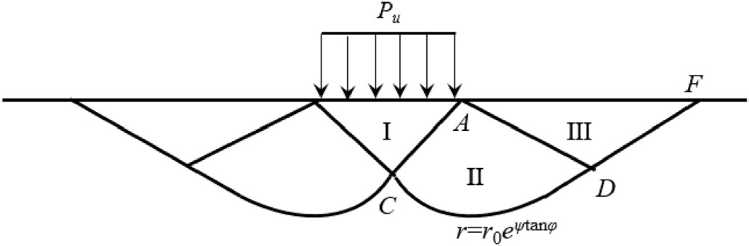
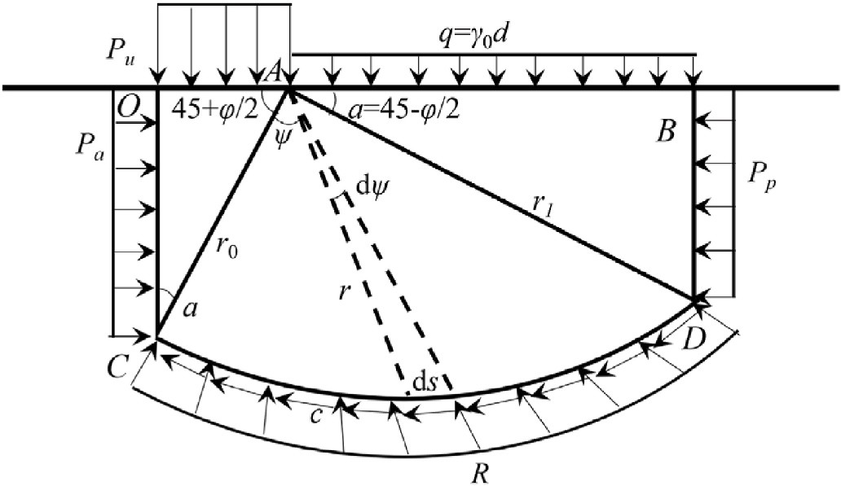
Fig. 1. Prandtl’s bearing capacity model [31]. Fig. 2. Prandtl-Reissner bearing capacity model [31].

Table 1
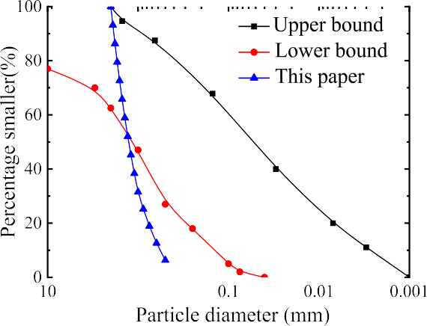
Parameters for lunar soil bin in DEM simulations [41].
Name Value
Void ratio 0.22
Dry density/kg/m³ 2600
Normal stiffness/(N/m) 7.5 × 10⁷
Tangential stiffness/(N/m) 5.0 × 10⁷
Frictional coefficient 1.0
Rolling resistance coefficient 1.3
Thickness of absorbed molecular layer/m 1.5 × 10^{—8}
Damping coefficient c_{n}, c_{s}/(kg/s) 0.4

Fig. 3. Grain size distribution in DEM sample [41].

ground is consolidated under different gravity fields ranging from 0.01 g to 10 g, as shown in Fig. 4. More details of the DEM simulations can be referred to in Ref. [27]. Thus, the hypotheses in Prandtl’s model can be
carefully examined and the gravity effect can be detailed analyzed by
the measurement circles arranged in the DEM grounds under different gravity effects, which can help modify Prandtl’s model considering the gravity effect.

    - Soil weight
A major limitation of Prandtl’s theory is its assumption of weightless soil, which prevents consideration of gravity effects. Thus, it is necessary to introduce the soil weight in the modified Prandtl’s theory. Taylor suggested that c + c’ can be employed to replace c in Prandtl’s theory to take the soil weight into consideration, where c’ refers to the increased shear strength due to soil weight [45]. Dewaikar and Mohapatra [46] proposed an analysis based on Prantal’s failure mechanism for the evaluation of bearing capacity factor N_{γ} using the limit equilibrium approach coupled with Kotter’s equation. Here the soil weight is directly introduced into the limit equilibrium analysis of Prandtl’s theory, as shown in Fig. 5. The soil weight of OAC and ABD can be easily added as
shown in Eq. (2), while the soil weight in ACD can be accumulated using integral calculus as shown in Eq. (3). The calculation details of the in-tegral calculus are provided in the appendix B.

    - Active earth pressure
The active earth pressure is assumed to act on OC in Prandtl’s theory, which can be easily examined in the DEM simulations by presenting the earth pressure acting on the left side wall, as shown in Fig. 4(a). Fig. 6(a)
presents the evolutions of the earth pressure acting on the left wall at different plate settlements s under 1 g gravity field. Note that the initial earth pressure at rest can be observed at the beginning of the test when s
= 0. As the plate settlement increases, the earth pressure on the shallow
wall gradually increases because of the additional pressure caused by the applied load, instead of the active earth pressure assumed in Prandtl’s theory. When the plate settlement exceeds 5 mm, the earth
pressure tends to be changeless. Thus the earth pressure acting on OC
includes two parts in the modified Prandtl’s theory, i.e., the initial earth pressure at rest P_{r} and additional pressure due to the applied load P_{add} as shown in Fig. 5.
In soil mechanics [31], the additional pressure P_{add} due to applied load P_{u} can be calculated using the following equation:
P_{add} = a₀P_{u} (4)

where a₀ is the coefficient of additional pressure due to applied load, which can be referred to in soil mechanics [31]. Fig. 6(b) provides the coefficient of additional pressure obtained from the DEM simulation at different gravity fields when s = 10 mm. Note that theoretical data in soil mechanics was also provided for comparison. It can be found that the coefficients of additional pressure in DEM simulations are quite close to the theoretical data and the gravity effect can be ignored. Thus the additional pressure due to the applied load can be calculated using the coefficient of additional pressure in soil mechanics and the gravity effect can be ignored.
Above all, the moments acting on OC include the moments due to

M = bhγ
1
2
b
1 b²hγ
earth pressure at rest and additional earth pressure, which can be

OAC 4
× 3 × 2 = 12
calculated as follows:

1 2 π tan φ 2 1
π tan φ b3
2 3π tan φ
1 2 1

MABD =
∫
b γ cot α⋅e 8
× 3 ×
2 b⋅cot α⋅e2
= 24
γ cot
α⋅e 2
(2)
M_{r} = γK₀h² ×
3 h =
γK₀h²
3
∫
(5)

Madd =
2
h
a₀P_{u}hdh
=
0
P_{u}b² ^{h}

4 ₀
a₀ cot ad(cot a) = a₁
P_{u}b²

4

r² (π φ
) 2 r³
(π φ )

M_{dψ} = 2 dψ⋅γ⋅r⋅cos 4 + 2 + ψ
π
⋅3 = 3 γ cos 4 + 2 + ψ dψ

∫ 2 r³ (π φ )

MACD =
0
3 γ cos 4 + 2 + ψ dψ
3π [
⎧⎪
tan φ
b
3
⎪⎨⎪ e 2 ⋅ 3 tan φ⋅cos
1

(3 φ)

4
2

(3 φ)] ⎫⎪

4
2

(3)
π +
+ sin
π +
— ⎪⎪⎬

= γ ⋅
⋅ ⎪ [
(1 φ)
(1 φ)] ⎪

24 sin³ α 9 tan² φ + 1
⎪
3 tan φ cos
⎩
4 π + 2
+ sin
4 π + 2 ⎪⎭

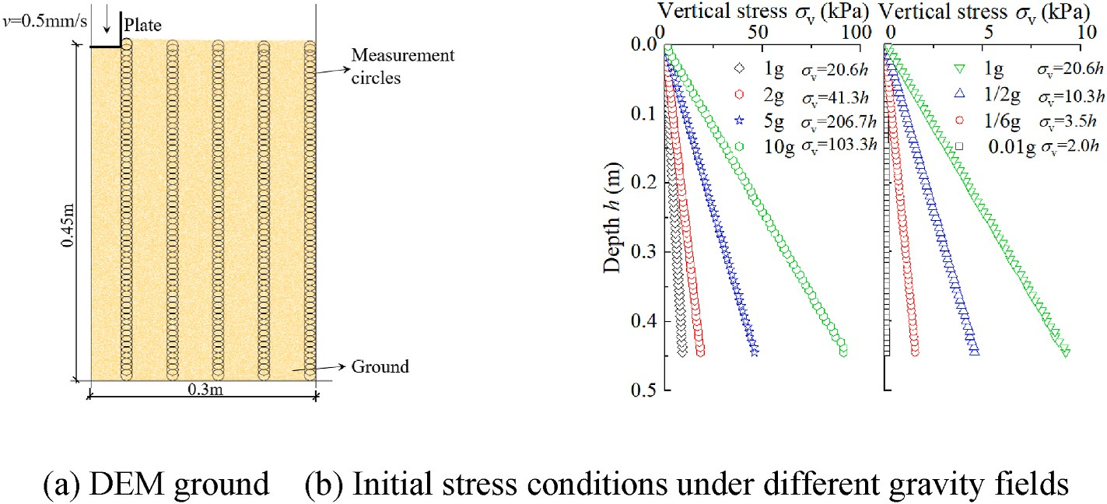

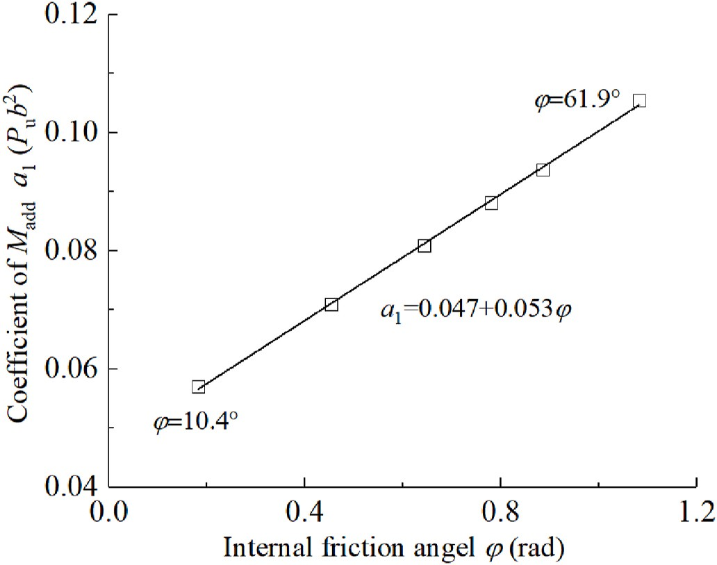
Fig. 4. DEM simulation of plate loading test [27].
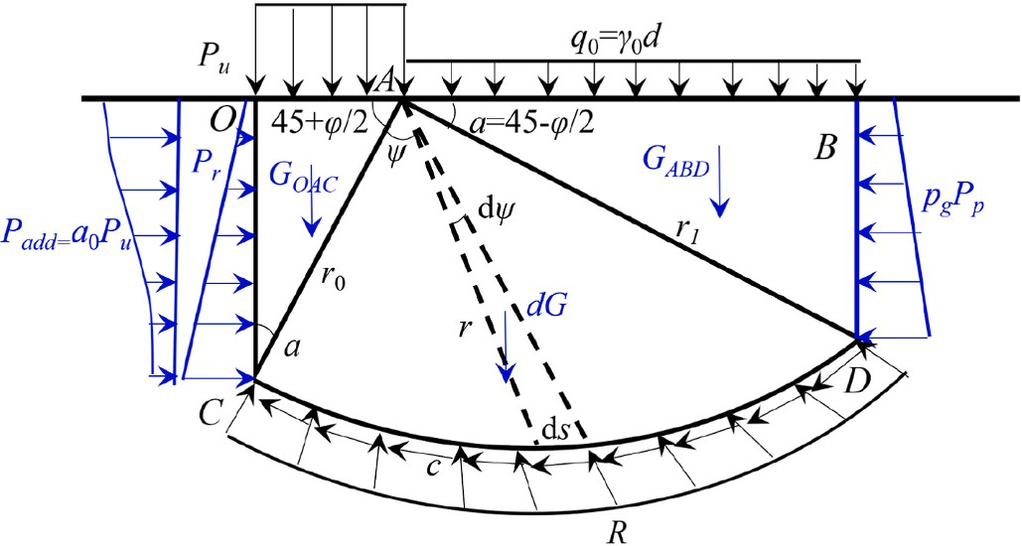
Fig. 5. Modified Prandtl’s model.

where a₁ is the coefficient of the moment due to additional earth pres-sure M_{add}, which depends on the internal friction angle φ. Note that a₀ is dependent on the depth h in a very comprehensive form and it is difficult to calculate the coefficient a₁ directly. Therefore, with the help of a₀ Table in soil mechanics [31], the relationship between coefficient a₁ and internal friction angle φ can be calculated, as shown in Fig. 7. It shows that M_{add} increases from 0.057 P_{u}b² to 0.105 P_{u}b² when φ increases from

Fig. 7. Relationship between coefficient a₁ and internal friction angle φ.

10.4◦ to 61.9◦, which can be described with a linear equation a₁ = 0.047
2
+ 0.053φ with R = 0.991. Consequently, M_{add} can be calculated using a₁P_{u}b /4, where a₁ can be referred to in Fig. 7.
2

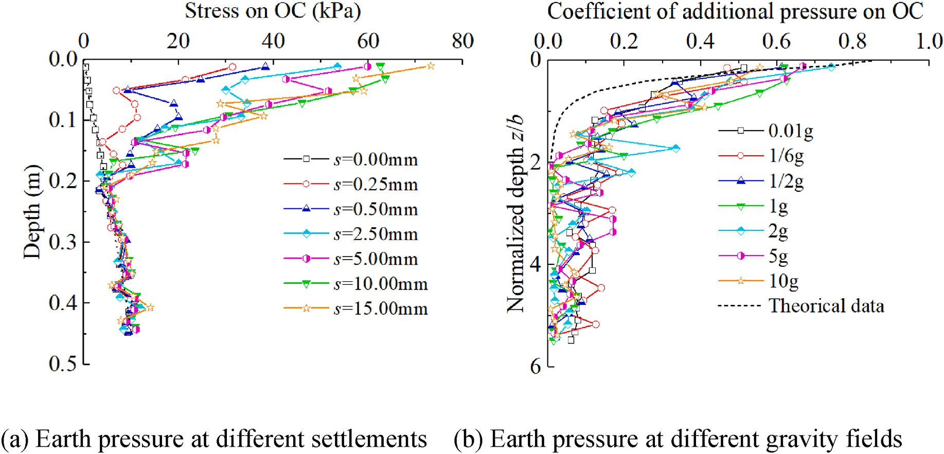

Fig. 6. Examination of the active earth pressure.

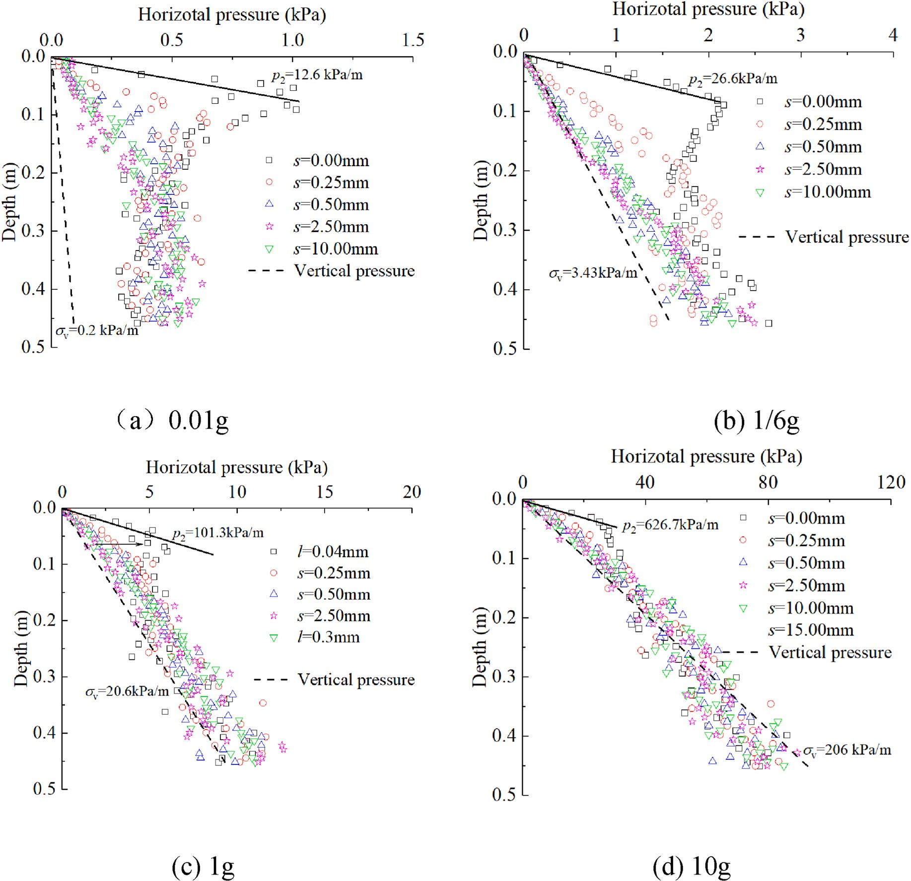

Fig. 8. Distributions of the horizontal earth pressures.

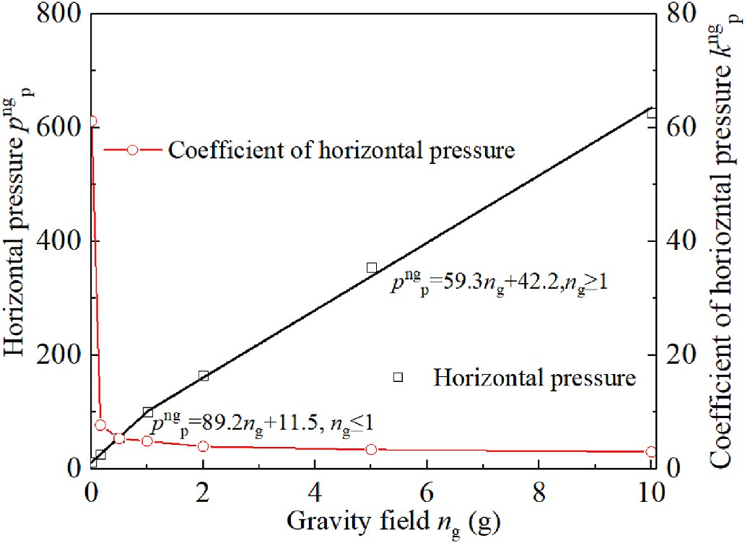
    - Passive earth pressure
The passive earth pressure is assumed to act on BD in Prandtl’s theory, which can also be examined in the DEM simulations of plate loading tests under different gravity fields. However, it seems difficult to
find the surface BD and obtain the earth pressure exactly in the DEM simulations. Therefore, five rows of measurement circles were arranged in the soil ground to monitor the horizontal earth pressure from the plate side to the boundary wall, as shown in Fig. 4. Fig. 8 presents the dis-tributions of the horizontal earth pressures P^{ng} in the ground when s = 10 mm under different gravity fields. It shows that the horizontal earth pressure increases significantly due to the applied load, and the increasing earth pressure is much larger in the soils nearer to the plate. In terms of the gravity effect, the maximum horizontal earth pressure under different gravity fields was provided in Fig. 9, as well as the co-
p
efficient of earth pressure (i.e., P^{ng}/n γg). It can be found that the hor-
p g

Fig. 9. Gravity effect on the horizontal pressure and coefficient of horizon-tal pressure.
izontal earth pressure increases disproportionately with the gravity field, and a bilinear line can be employed to describe the relationship between the horizontal earth pressure and gravity field, which is in agreement with that between the ultimate bearing capacity and gravity field [27]. In addition, the horizontal earth pressure increases more significantly in the lower gravity fields compared with the initial stress, especially in 0.01 g gravity fields. This can be easily understood that the

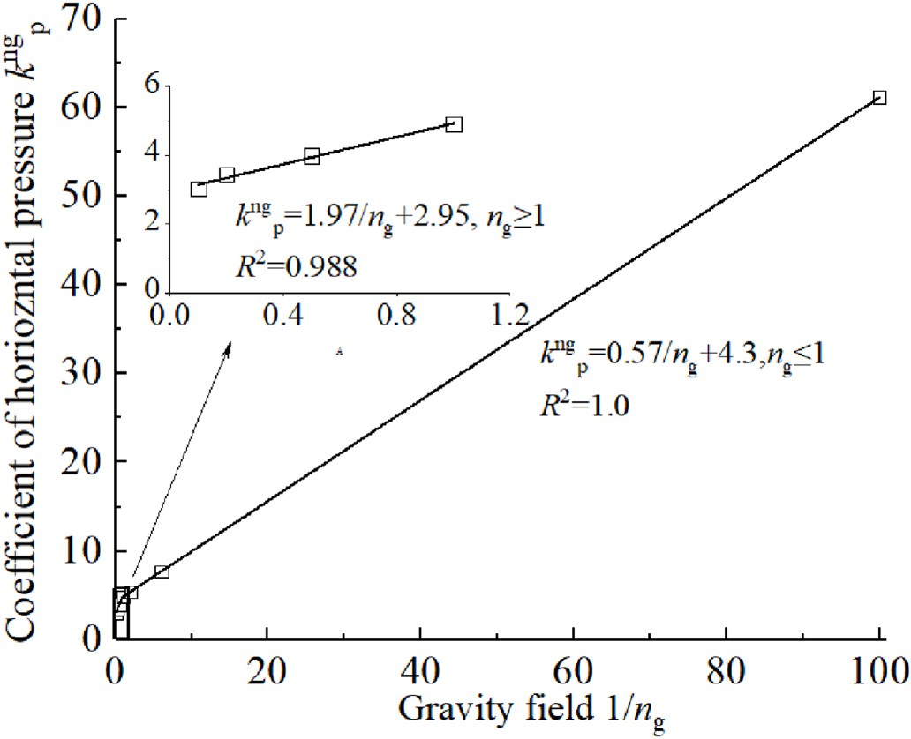
smaller than 6.5 %. Therefore, the k^{ng} can be calculated using the
p

following equation:
k^{ng} = k_{p} 1 / n_{g} — 1) + k^{1g}
p
p

(6)

where k_{p} represents the gravity effect on the coefficient of passive pressure.
In addition, a linear line, k^{ng} = k log (n ) + k^{1g}, can also be used to
p
1
10
g
p
describe the relationship between k^{ng} and log (n ) when n falls in 1/
p 10 g g
6–10 with the fitting error R² = 0.927 as shown in Fig. 11. The intercept refers to the coefficient of passive earth pressure on Earth, i.e., 5.14 in
the fitting which is quite close to theoretical value on Earth (i.e., 5.19). Thus such a fitting may be more practical because the intercept repre-sents the coefficient of passive pressure on Earth, while the slope rep-resents the gravity effect on the k^{ng}.
p

Fig. 10. Relationship between the coefficient of horizontal pressure k^{ng} and gravity field 1/n_{g}.
p

soils in low gravity are more easily affected by the applied load than those in a high-gravity field, which implies that the gravity effect on the earth pressure acted on BD should be taken into consideration. For this aim, a gravity-dependent coefficient of passive earth pressure, k^{ng}, should be employed here to replace the passive earth pressure in
p
Prandtl’s theory with k^{ng}γh, as shown in Fig. 9. It shows k^{ng} decrease
    - Failure surface
In classical soil mechanics, the internal friction angle φ increases with the decreasing confining pressure (stress level), mainly because of particles interlocking, shear dilatancy, particle breakage, and grain rearrangement et al. [31]. Within the classical soil mechanics frame-
work, characterization of soil strength over appropriate stress is neces-sary to ensure safe geotechnical designs, e.g., nearly 30–3000 kPa in rock-fill dams [47], and 5–20 kPa in shallow landslides [48]. Perkin [30]
also stated that the soil strength dependency on the stress state should be taken into consideration when predicting the bearing capacity of lunar simulants under different gravity fields. In the DEM simulation, the affected area was found to become deeper in depth and wider in width as the gravity level decreased in the high-vacuum environment. This can be

p p easily understood that the internal friction angle φ increases with the

with the increasing gravity field significantly, especially in the low gravity field. Such reduction can hardly be clarified only by the stress dependence of strength parameters.
Fig. 10 provides the relationship between the k^{ng} and 1/n . It shows
decreasing gravity field, which deduced deeper and wider affected areas in Prandtl’s model. Fannin et al. [48] stated that a linear line can be used to describe the relationship between the internal friction angle and the

ng p g confining pressures for soils on Earth (Fig. 12(a)), which is also suitable

that a bilinear line k_{p} n=g
relationship between k_{p}
k_{p}/n_{g} + b can be employed to describe the
and 1/n_{g}. This can be easily understood by
for lunar simulants (Fig. 12(b)) according to the experimental data by Perkin and Madson [29].

introducing k^{ng} = P^{ng}/n γg into the relationship between the P^{ng} and n . ( )
p
p
g
p
g

In addition, when n_{g} 1, k_{p} b equals the coefficient of passive earth pressure on Earth, k^{1g}, i.e., 4.87 and 4.92 in the fitting curve, which are
p
= +
φ_{ng} = k_{φ} log10
png
+ b (7)

quite close to the theoretical value on Earth(i.e., 5.19) with errors
where k_{φ} and b are the fitting parameters. For simplification, the confining pressure is assumed proportional to the gravity effect, i.e., p_{ng}
= n_{g}p_{1g}. Thus the gravity effect on the failure surface, which depends on
the internal friction angle, can be easily described using the following equation:
φ_{ng} = k_{φ} log10(n_{g}p_{1g}) + b = k_{φ} log10 n_{g}) + log10(p_{1g}) + b = k_{φ} log10 n_{g})
+ φ_{1g}

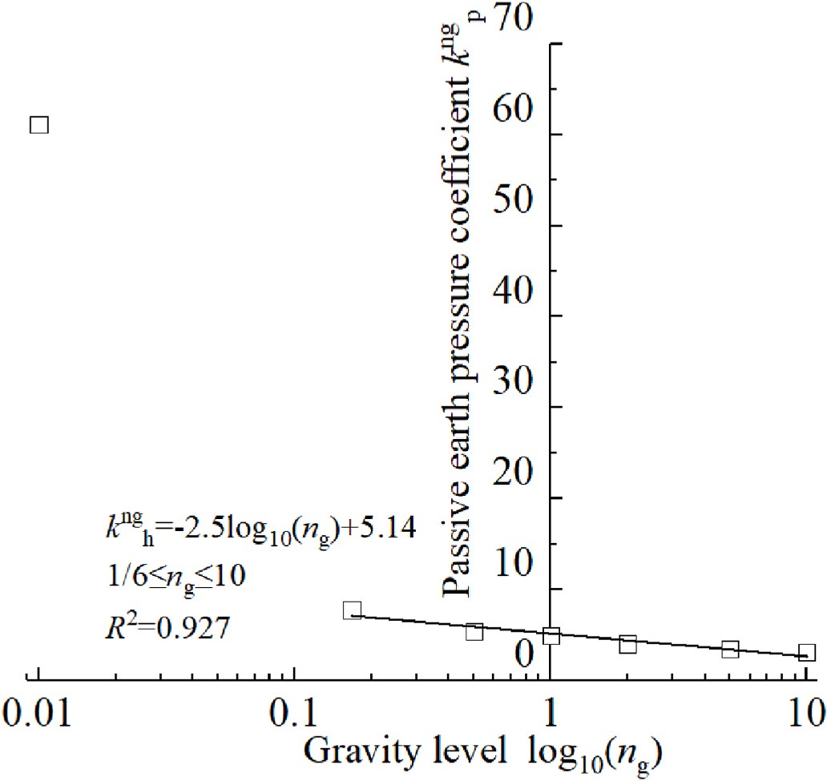
(8)
Note that k_{φ}log₁₀(n_{g}) represents the increasing internal friction angle due to the gravity effect, and φ_{1g} represents the internal friction angle on Earth. The parameter k_{φ} can be determined using in-door experimental data, e.g., —6.7 for MLS-1 lunar simulant and —4.2 for JSC-1 lunar simulant. Moreover, the soil cohesion c was assumed stress-independent here in the light that lunar soil can be regarded cohesionless.

  - Model derivation

The total moment to point A should be 0 according to the limit equilibrium method [31]. Based on the geometrical relationship, the moment can be calculated one by one as follows:

Fig. 11. Relationship between passive earth pressure coefficient k^{ng} and gravity
p
- Surface OA: On the surface OA, only the ultimate bearing ca-pacity P_{u} applied a moment to the point A, which can be expressed as:

level log₁₀(n_{g}).

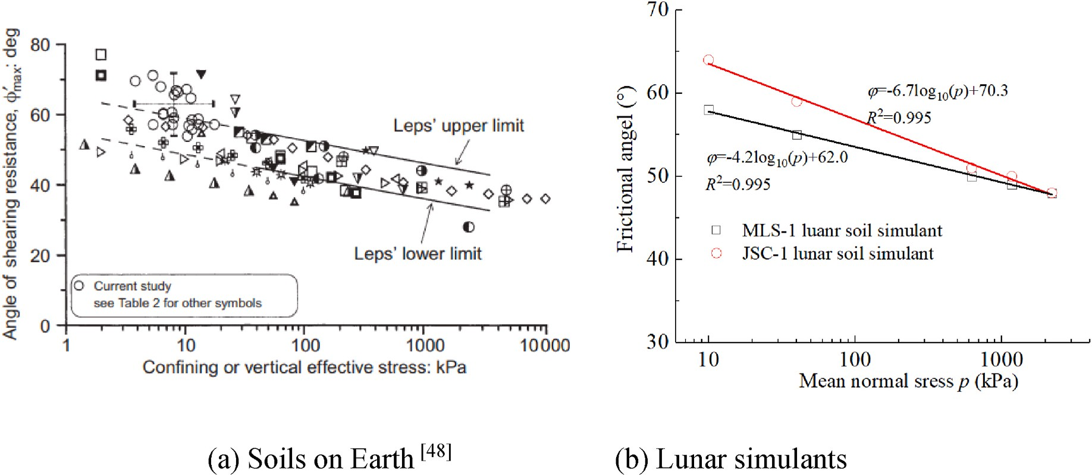

Fig. 12. Relationship between inter-frictional angle and the confining pressures.

1 passive earth pressure. Note that the relationship between k^{ng}

M_{OA} = b²P_{u} (9)
p
1g 1g 2

8
- Surface OC: As stated in section 3.1, the forces acting on OC include the earth pressure at rest and additional earth pressure due to applied load. Thus the moment can be calculated using the following equation:
in section 3.1.3 was calculated with k_{p} (i.e., k_{p} = tan (45 +
φ_{1g})), while the coefficient of passive earth pressure is calculated using tan²(45+φ_{ng}) in the model derivation. Thus a modified coefficient p_{g} was employed here to introduce the gravity effect on the coefficient of passive earth pressure in the model deriva-tion as follows:

MOC
P_{u}b² cot² a
= 8
(1 — sin φ) +
γb³ cot³ a 24
(1 — sin φ) + a₁P_{u}b² (10)
p_{g} tan² 45 + φ_{ng} / 2) = k^{ng} = k_{p} 1 / n_{g} — 1) + tan² 45 + φ_{1g} / 2) (14)
Therefore, the moment due to the gravity-dependent passive earth pressure can be expressed as:
p
α +
⋅cot α

3) Area OAC: The soil weight of area OAC applied a moment to point A
cot a 3
M_{BD} =
p_{g}b q₀⋅e
8
⋅cot
p_{g}b c⋅e
2
b

as follows:

1 2 π tan φ 2
1 ,̅̅̅̅̅ ₂

4

π tan φ
3π tan φ

1
4
MOAC =
bhγ × × =
b γ (11)
b3
+ p_{g} cot²
24
α⋅γ⋅e 2
(15)

- Surface AB: On the surface AB, the surcharge stress q₀ = γ₀d exerts a moment to point A as:
3
2
24
1
- Surface CD: On the surface CD, the cooperate force R of normal and frictional forces points to A, and the moment can be regarded as 0 [31]. Thus only the cohesion c applied a moment to point A

M_{AB} =
q₀b²⋅cot² α⋅e^{π} ^{tan} ^{φ} (12)
8
as follows:
∫ _{l}

∫ ₂ 2
π
0

2 1

π tan φ

- Area ABD: The soil weight of area ABD applied a moment to point
M_{c} =
c ⋅ ds ⋅ r cos φ
0
=
cr dθ = cr₀ 2 tan φ (e
— 1)

(16)

A as follows:
3
b²c⋅cot φ⋅(e^{π} ^{tan} ^{φ} — 1)

8 sin α
= ₂

M = b γ cot²
ABD 24
α⋅e 2
3π tan φ
(13)

- Area ACD: The soil weight of area ACD applied a moment to point

- Surface BD: On the surface BD, both the soil cohesion c, surcharge stress q_{0,} and soil weight contribute to the gravity-dependent
A as introduced in section 3.1.

b³ 1
M_{ACD} = γ 3 ⋅ 2
⋅⎪⎨ [
4 2
( ) (
4 2 ⎪
)]
⎬
(17)

24 sin
α 9 tan
φ + 1
⎪
⎪⎪⎧ e3π tan φ ⋅[3 tan φ⋅cos(3 π + φ) + sin(3 π + φ)]— ⎫⎪
2
3tanφ cos
1 π + φ
+ sin
1 π + φ ⎪

⎪⎩ 4 2 4 2 ⎪⎭

Table 2
Equations for the bearing capacity factors.

Factors Equations Theoretical models
N_{q} Nq = tan2 (45 + φ)eπ tan φ Prandtl Theory
2
Above all, the total moments acting on A equals 0 according to the limit equilibrium criterion as follows:
∑ MA = MOA + MOC + MOAC + MACD — MAB — MABD — MBD — MBD — MC
= 0

e(3π/2—φ)tan φ
Nq = 2 cos2 (45 φ)
2
= — )
+

Terzaghi theory
(18)
Thus the ultimate bearing capacity P_{u} can be expressed using Eq.

N_{c} Nc cot φ Nq 1 Prandtl Theory Terzaghi Theory
Nγ Nγ = tan(45 + φ)[e^{π} ^{tan} ^{φ} tan²(45 + φ) — 1] Liao et al. [45]

(18), where the coefficients of bearing capacity N_{r}, N_{q}, N_{c} mainly depend on the gravity-dependent internal friction angle φ = φ_{ng} using Eq. (8) and gravity coefficient of passive earth pressure p_{g} using Eq. (14).

2 2
π+3π² tan φ 2 π Hjiaj et al. [49] 1

φ)5
Nγ = e 6 ) (tan
Nγ = N
— 1 tan(1.32φ) Salgado [50]
u
0
q
c
2
q

P = γ dN + cN + γbN_{γ} (19)

Nγ Nq 1 tan 1.4φ Meyerhof [51]
= — ) ( )
Nγ = 1.5 Nq — 1)tan φ Hansen [52]
)
cot² α⋅e^{π} ^{tan} ^{φ}⋅(1 + p_{g})

Nγ = 2 Nq — 1 tan φ Eurocode [53]
1
Nγ e0.66+5.11 tan φ tan φ Michalowski [54]
=
Nγ = 2 Nq + 1)tan φ Vesic [55]
Nq = 1 + 8a + cot² α(1 — sin φ)

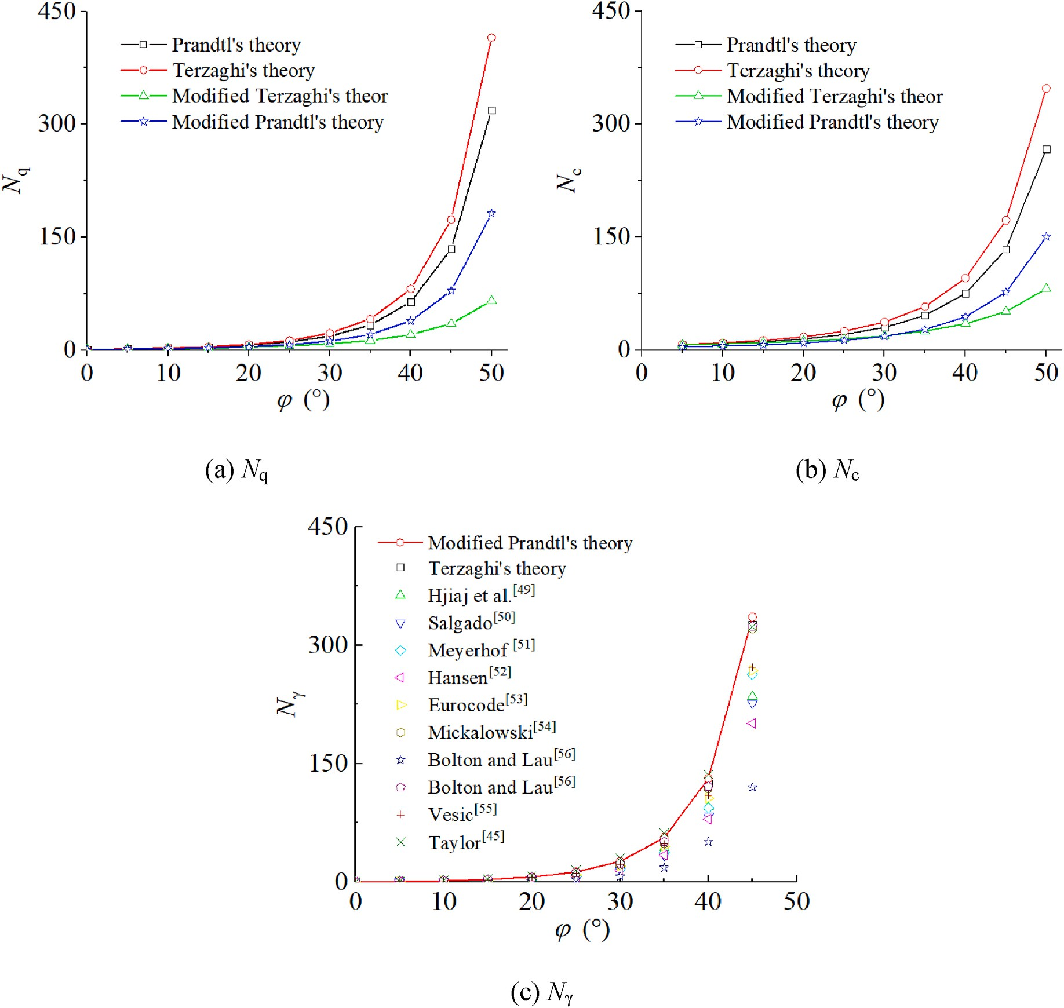

Fig. 13. Bearing capacity factors using different equations.

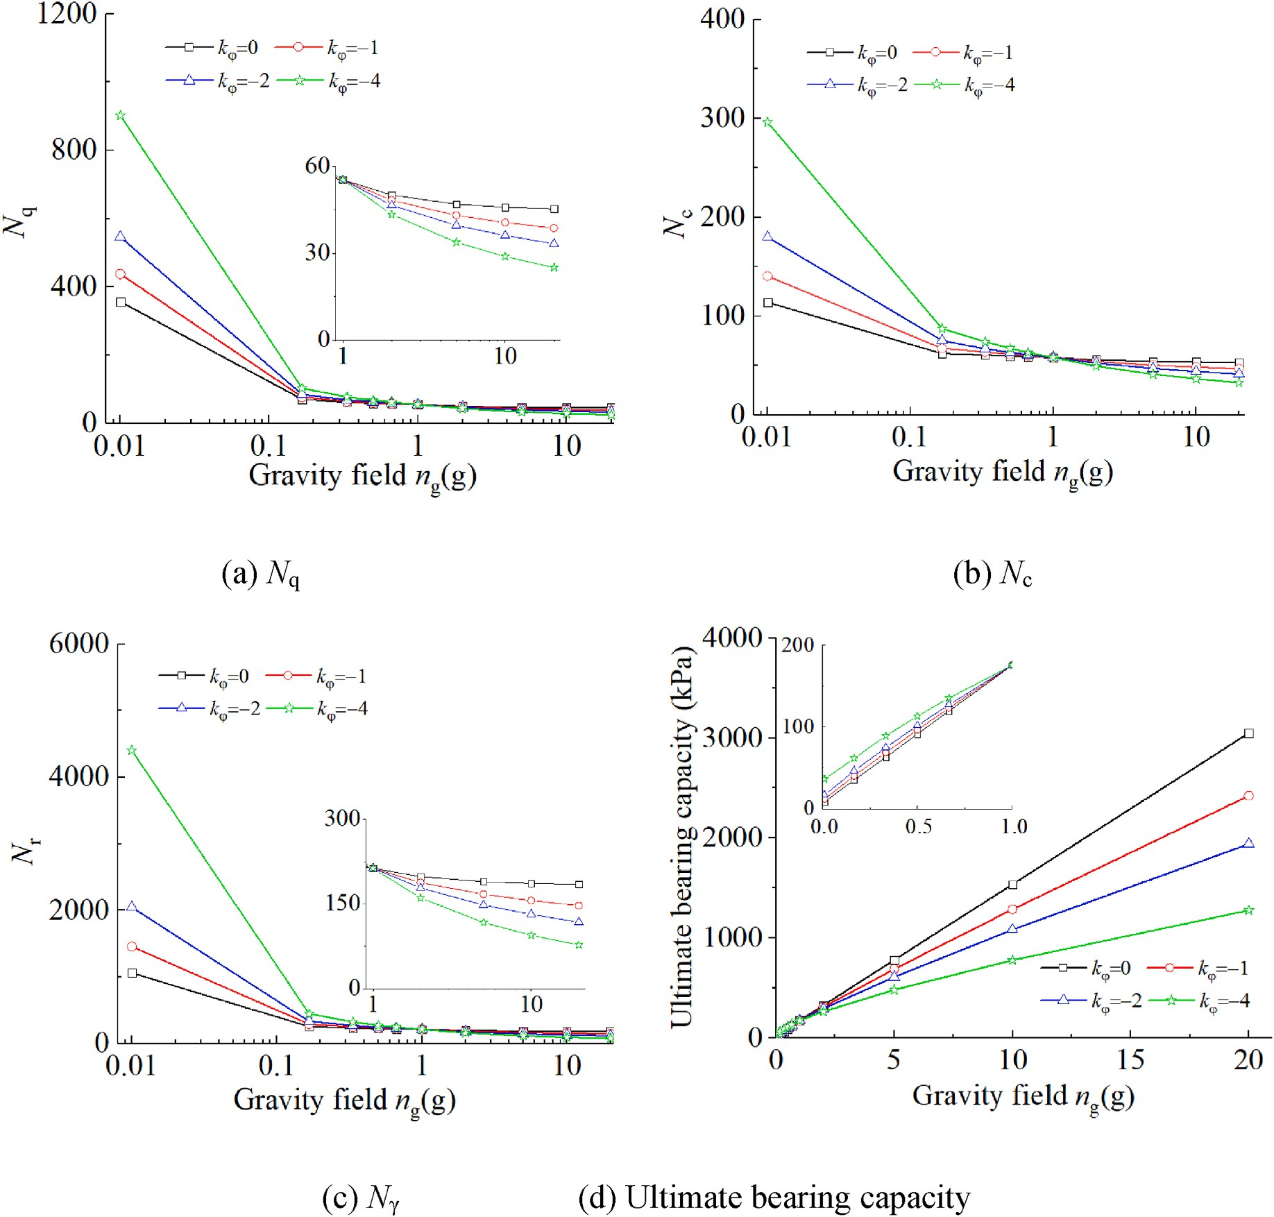
Fig. 14. Effect of k_{φ} on the bearing capacity factors and ultimate bearing capacity.

[ π tan φ ,̅̅̅̅̅
1
cot φ⋅(e^{π} ^{tanφ} — 1)] 4. Calculation results

Nc =1+ 8a +cot² α(1—sin φ) 2e
1
⋅ p_{g} cot α+
sin² α

- Bearing capacity factors

Up to now, various equations have been suggested for calculating the bearing capacity factors [56], especially for N_{r}, as shown in Table 2.

2
N_{γ} = ⋅
cot α⋅e 2
2
2 3π tan φ
⋅(1 + p_{g})
2 1
— ₂
[

cot α +
cot³ a

(1 — sin φ)]—

3 1 + 8a₁ + cot
a(1 — sin φ)
1 + 8a₁ + cot a(1 — sin φ) 3 3

⎪⎪⎧ e3π tan φ ⋅[3 tan φ⋅cos(3 π + φ) + sin(3 π + φ)]— ⎫⎪
2
1
⋅⎪⎨
2
4
2
4
2
⎪⎬

1 + 8a₁ + cot² a(1 — sin φ) 3 sin³ α(9 tan2 φ + 1) ⎪ [
⋅
(1 φ)
(1 φ)] ⎪

3 tan φ cos
⎩
⎪
4 π + 2
+ sin
4 π + 2 ⎪⎭

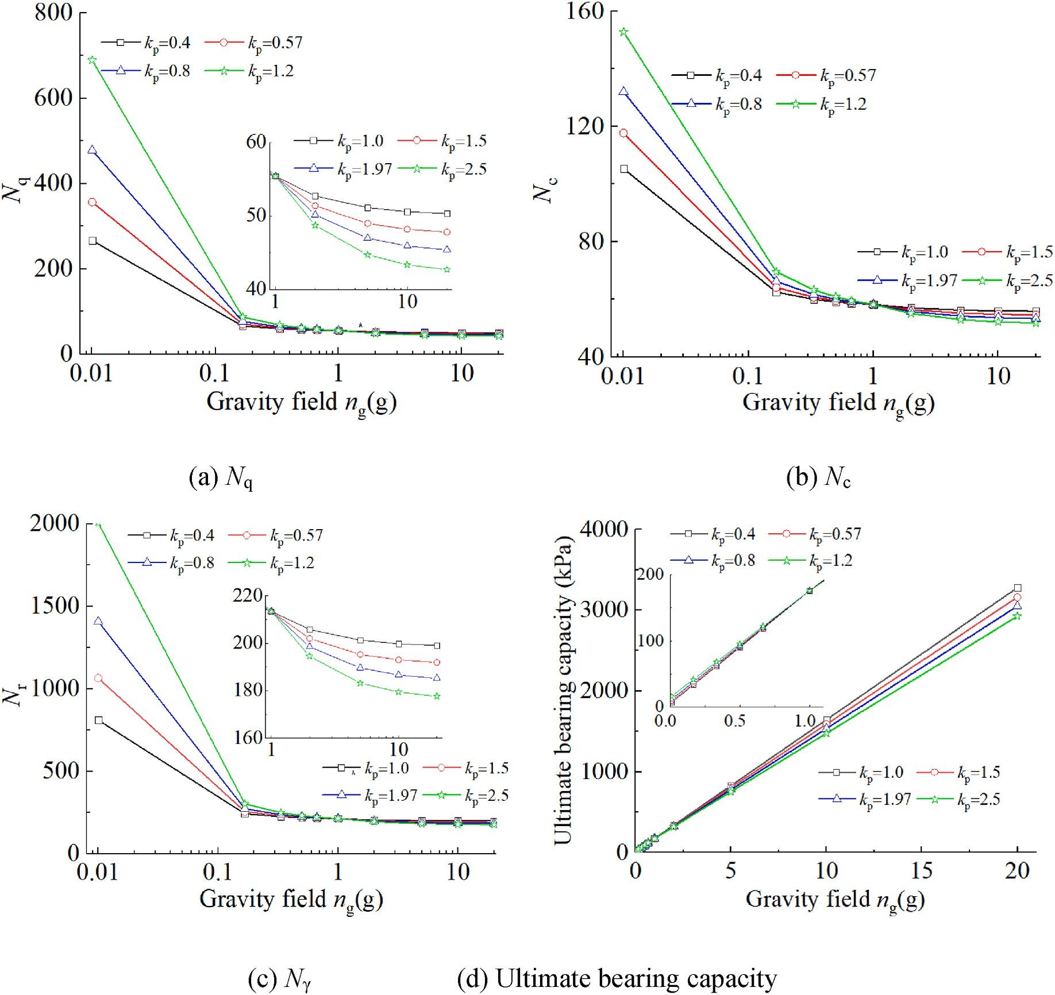

Fig. 15. Effect of k_{p} on the bearing capacity factors and ultimate bearing capacity.

Table 3
Parameters for the modified Prantle model.
Soil φ(◦) ρ(g/ k_{φ} k_{p} Parameters in
Fig. 13 provides the bearing capacity factors using the modified Prandtl’s theory, as well as those using the equations in Table 2. It shows that the factors N_{c} and N_{q} using the modified Prandtl theory are smaller
than those of Prandtl and Terzaghi theories, but larger than those pre-

cm³)
references
dicted by the modified Terzaghi theory (i.e., φ_{m} = arctan(2/3tanφ)).

KLS-1 simulant [28]
40.6 1.63 —3.2 1.97(n_{g} >
1)
φ = 40.6◦,c = 1.716
kPa, ρ 1.46–1.8 g/ cm³
=
This is because the earth press at rest and additional pressure due to the
applied load P_{u} are employed instead of the active pressure. Moreover, it is interesting that the predicted values of N using the modified Prandtl s

MLS-1 simulant
54.5 2.2 —3.2 0.57(n_{g} >
φ = 48–58◦, ρ = 2.2 r ’

[29]
FJS-1 simulant (D_{r} = 60 %) [23]
FJS-1 simulant (D_{r} = 90 %) [23]
Toyour sand (D_{r} = 60 %) [23]
Toyour sand (D_{r} = 90 %) [23]
Quartz sand
[24]
1)
41.6 1.77 —3.2 1.97(n_{g} >
1) and 0.57
(n_{g} < 1)
51.5 1.95 —3.2 1.97(n_{g} >
1) and 0.57
(n_{g} < 1)
47 1.51 —3.2 1.97(n_{g} >
1) and 0.57
(n_{g} < 1)
50 1.61 —3.2 1.97(n_{g} >
1) and 0.57
(n_{g} < 1)
53 1.55 —3.2 0.57(n_{g} <
1)
g/cm³
φ = 41.6◦,c = 1.44
kPa,ρ = 1.77 g/cm³

φ = 50.1◦,c = 7.54
kPa,ρ = 1.95 g/cm³

φ = 38.1◦,c = 3.04
kPa,ρ = 1.51 g/cm³

φ = 42.7◦,c = 3.04
kPa,ρ = 1.61 g/cm³

ρ = 1.55–1.56 g/cm³
theory are quite close to those of Terzaghi’s theory with differences
smaller than 4 %, while the predicted values using the other equations in Table 2 are smaller.

- Gravity effect on bearing capacity coefficients

As stated in Section 2, the gravity effect was taken into consideration by introducing the stress-dependent coefficient k_{φ} in Eq. (8) and gravity-dependent coefficient k_{p} in Eqs. 6 and 14 for passive earth pressure, which depends on the soil material. Fig. 14 shows the effect of k_{φ} on the bearing capacity factors and bearing capacities at different gravity fields when φ_{1g} = 42.6◦, c = 0.0 kPa, k_{p} = 1.97 (n_{g} > 1), and k_{p} = 0.57 (n_{g} < 1).

Fig. 14 shows that the bearing capacity factors increase with the decreasing gravity field significantly. The higher the k_{φ}, the more the bearing capacity factors increase. The predicted bearing capacities are

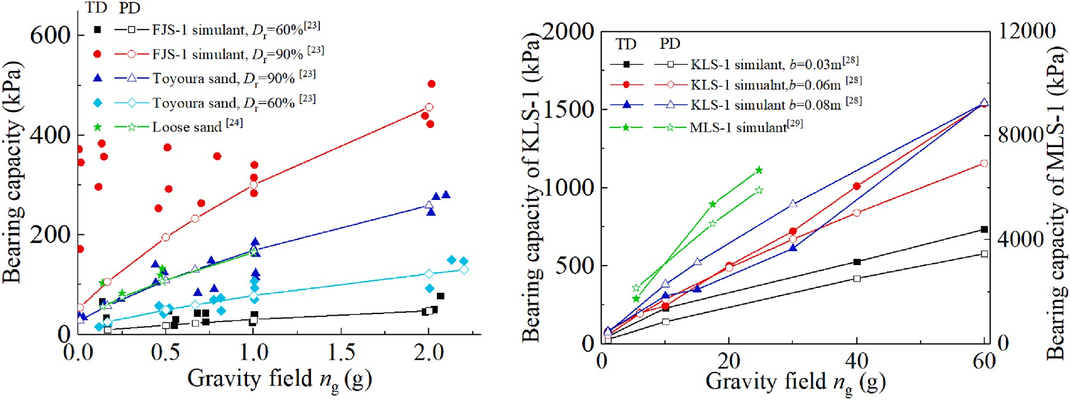

Fig. 16. Comparison between the experimental data and predicted data.
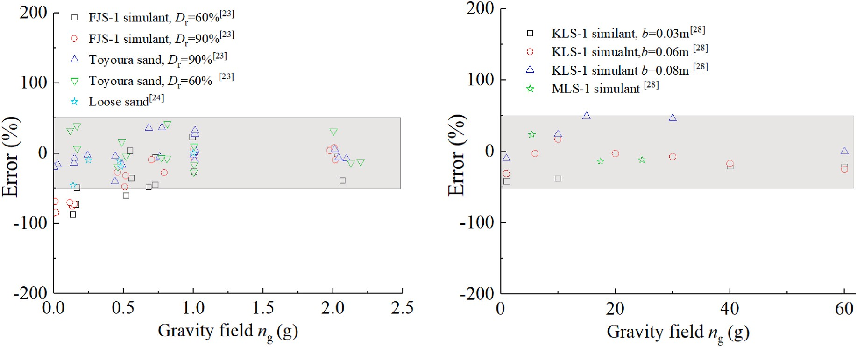

Fig. 17. Relative errors under different gravity fields.

provided in Fig. 14(d). It can be found that the bearing capacity in-creases with the decreasing gravity field well, and a nin-linear line can be employed to describe the gravity effect on the bearing capacity. Note that when k_{φ} = —4, the bearing capacity under 0.01 g gravity is larger than that under 1/6 g gravity, this is because the gravity effect on the
bearing capacity factor N_{r} is more significant than on the soil density.
Fig. 15 shows the effect of k_{p} on the bearing capacity factors and bearing capacities at different when φ_{1g} = 42.6◦, c = 0.0 kPa, and k_{φ} = 0. It can be found that the bearing capacity factors increase with increasing k_{np} under a low gravity field (i.e., n_{g} < 1) and decreases with increasing
k_{np} under a high gravity field (i.e., n_{g} > 1). As a result, the ultimate
bearing capacity increases with the increasing k_{np} under a low gravity

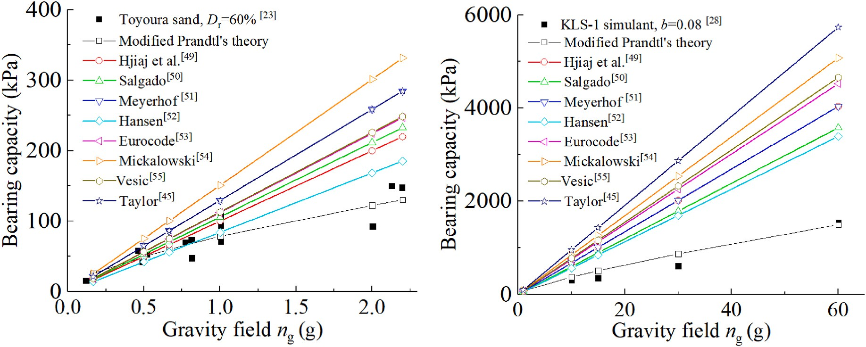

Fig. 18. Comparison with classical models.

field (i.e., <1 g) and decreases with increasing k_{np} under a high gravity field (i.e., > 1 g). In addition, it seems that the stress-dependent coef-ficient k_{φ} affects the bearing capacity of soils under different gravity fields more than k_{p.}

- Comparison with experimental data

Up to now, numerous plate loading tests under both low and high-gravity fields have been performed to study the gravity effect on the bearing capacity, and the experimental data can be employed to verify
the modified Prandtl’s model. Note that the plate width is usually small (i.e., 0.01m–0.08m) in most physical model tests, and the soil cohesion shows a more significant effect on the predicted bearing capacity than
the soil density, especially in low gravity fields. For simplification, most research assumes that sands and lunar soil simulants are cohesionless (i. e., c = 0 kPa) to compare the theoretical data with experimental results [28,29]. In addition, the strength parameters in the original paper are unprovided [24] or inaccurate in predicting the bearing behavior of the soils, probably due to experimental error. For example, Kobayashi et al.
[23] provided a much smaller bearing capacity (i.e., nearly 32.3 kPa) of FJS simulant (φ = 41.6◦, c = 1.44 kPa) than that (i.e., nearly 154 kPa) of Toyoura sand with similar strength parameters (i.e., φ = 42.7◦ and c = 3.04 kPa when D_{r} = 90 %), even much smaller than that (i.e., nearly 90 kPa) of Toyoura sand with smaller strength parameters (φ = 38.1◦ and c
= 3.04 kPa when D_{r} = 60 %). Therefore the inter friction angle under 1 g gravity field φ_{1g} was calculated using the bearing capacity under 1 g gravity field in some research instead of the provided one in some
comparisons as shown in Table 3. The stress-dependent parameter of soil strength k_{φ} can be measured by fitting the relationship between the soil strength and confining pressures, here k_{φ} is chosen to be —3.2 for sim-ification. The passive earth pressure coefficient k_{p} is assumed to be 0.57
under low gravity fields and 1.97 under high gravity fields approxi-mately as suggested in Fig. 8. Fig. 16 provides the comparison between the experimental data (TD) and predicted data (PD) with the modified Prandtl’s model, while the relative errors are provided in Fig. 17. It
shows that the modified Prandtl’s model predicts bearing capacities
within 50 % error of experimental data under different gravity fields, which implies that the modified Prandtl’s model can be employed to predict the bearing capacity of lunar soil and its simulants under
different gravity. It is worth mentioning that the available experimental data exhibits relatively poor repeatability and significant spatial vari-ability with large experimental errors due to testing procedure in-consistencies (e.g., significant temporal fluctuations and instability in the aircraft-generated low-gravity field) and material heterogeneity (e. g., slight variations in ground preparation). For example, the maximum bearing capacity of FJS-1 simulant (D_{r} = 90 %) in nearly 0 g gravity is about 370 kPa while the minimum value is 171 kPa with an error of 112
% [23]. The bearing capacity of the KLS-1 simulant under a plate of 0.06m (i.e., 722 kPa) is larger than that under a plate of 0.08m (i.e., 612 kPa) in the centrifuge tests [28]. The modified Prandtl’s model also
involves some deficiencies, e.g., the limit equilibrium method was
employed. Thus a 50 % error is acceptable for this modified Prandtl’s model. An empirical correction is necessary based on more reliable experimental results to help improve the accuracy in the view of
geotechnical engineering.

- Comparison with classical models

Fig. 18 provides the comparison between the predictions using classical models and modified Prandtl’s model, as well as experimental data from the centrifuge tests [28] and flying airplanes [23]. Fig. 18
shows that the predicted bearing capacities using classical models are directly proportional to the gravity level, while the bearing capacity obtained from centrifuge tests and flying airplanes increased non-linearly with the gravity field. This implies that classical models cannot capture the gravity effect on the bearing capacity. In addition, it
can be observed that the modified Prandtl’s model provides a much closer prediction of bearing capacity to the experimental data than the classical models.

5. Conclusions

In this paper, a modified Prandtl’s model considering the gravity effect was developed aiming to provide a method for calculating the bearing capacity of soils under extraterrestrial gravitational environ-
ments. The assumptions in Prandtl’s bearing capacity theory were
carefully examined and the gravity effect on such assumptions was detailly analyzed based on previous DEM simulations of plate loading tests under different gravity fields. Then the modified Prandtl’s model
was developed and verified by comparing the predicted values with
existing experimental data under different gravity fields. The major conclusions are as follows:

- Based on the DEM simulations, the sum of earth pressure at rest and additional pressure due to applied load should be employed instead of the active earth pressure, and the passive earth pressure increases non-linearly with the gravity field, which can be fitted using a bilinear line bounded by 1 g.
- The gravity-dependent soil weight, gravity-dependent passive earth pressure, and stress-dependent soil strength were introduced to develop a modified Prandtl’s model as well as the earth pressure at
rest and additional pressure due to applied load. The modified model
provides a similar N_{r} with the Terzaghi theory with differences smaller than 4 %, while the predicted N_{c} and N_{q} are smaller than those of Prandtl and Terzaghi theories.
- The predicted values with the modified Prandtl’s model are close to
the experimental data with errors smaller than 50 % under different gravity fields, which implies that the modified Prandtl model can well capture the gravity effect on the bearing capacity of lunar soil and its simulants observed in existing experimental tests. The pro-posed model can serve as an effective tool in the design and con-struction of the future lunar base instead of the classical models.

Note that there are still some deficiencies in the model derivation, e. g., Prandtl’s slip line was employed, and an accurate prediction of bearing capacity cannot be obtained by this model. An empirical
correction is desperately necessary based on more reliable experimental data to help improve the accuracy in the view of geotechnical engi-neering. In addition, the key gravity-depend parameters k_{φ} and k_{p} are
also determined with limited experimental and numerical data, which
needs more experimental data to be confirmed with confidence.

CRediT authorship contribution statement

Banglu Xi: Writing – review & editing, Writing – original draft, Visualization, Validation, Methodology, Conceptualization. Mingjing Jiang: Writing – review & editing, Investigation, Conceptualization. Lin Qi: Writing – review & editing, Visualization. Jiaqiang Yang: Writing – review & editing, Validation. Mingliang Chen: Writing – review & editing, Validation.

Declaration of competing interest

The authors declare that they have no known competing financial interests or personal relationships that could have appeared to influence the work reported in this paper.

Acknowledgments

The research is funded by the National Natural Science Foundation of China with Grant No. 52209127, the Fundamental Research Funds for the Central Universities with Grant No. JZ2024HGTB0206, and the

Anhui Provincial Natural Science Foundation with Grant Nos. 2408085QE154 and 2308085QE191, all of which are sincerely
appreciated.

Appendix A. Main notation

α: angle between the boundary of Rankine passive zone and horizontal surface, a = π/4-φ/2
α0 : coefficient of additional pressure due to applied load (unitless)
a1: coefficient of the moment due to additional earth pressure M_{add} (unitless)
b: plate width (m)
c: apparent cohesion of soil (kPa)
c’: increased shear strength due to soil weight (kPa)
d: the depth of the overburden soil (m)
φ: internal friction angle of soil (◦)
φ_{ng}: internal friction angle of soil under ng gravity field (◦)
φ_{1g}: internal friction angle of soil under 1 g gravity field (◦)
h: depth of the Rankine active zone (m)
k^{ng}: gravity-dependent coefficient of passive earth pressure (unitless)
p
kp: coefficients representing the gravity effect on k^{ng} (unitless)
p
kφ: coefficients representing the gravity effect on φ (unitless)
ng: coefficient of gravity level (unitless)
q0 : surcharger pressure (kPa)
ρ: density of the soil in the ground (g/cm³)
pg: coefficients representing the gravity effect on passive earth pressure
γ: weight of the ground soil (kN/m³)
γ₀: weight of the overburden soil (kN/m³)
s: plate settlement (mm)
K0 : coefficient of earth pressure at rest (unitless)
Nc, Nq, Nγ: coefficients of bearing capacity (unitless)
Pu: ultimate blearing capacity (kPa)
Pa, Pp: active and passive Rankine earth pressures (kPa)
Pr: initial earth pressure at rest (kPa)
P_{add}: additional pressure due to applied load (kPa)
P^{ng}: passive earth pressure at n_{g} gravity field
p

Appendix B
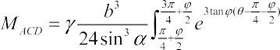
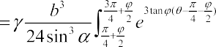
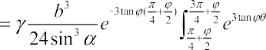
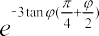
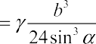
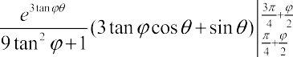
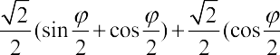
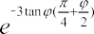
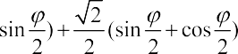
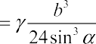
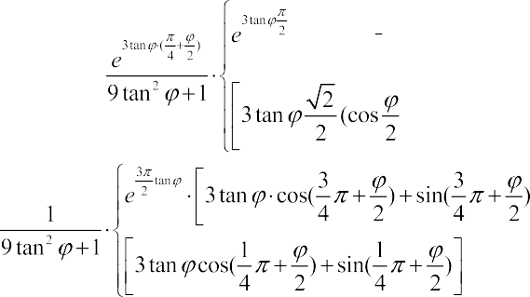

References

- T. Herzig, N.I. Ko¨mle, W. Macher, G. Bihari, P. Gl¨aser, Site selection, thermodynamics, environment and life support analysis for the PneumoPlanet inflatable lunar habitat concept, Planet. Space Sci. 224 (2022) 105595.
- M. Troemner, E. Ramyar, J. Meehan, B. Johnson, N. Goudarzi, G. Cusatis, A 3D-printing centered approach to Mars habitat architecture and fabrication, J. Aero. Eng. 35 (2022) 04021109.
- M.B. Duke, W.W. Mendell, B.B. Roberts, Strategies for a permanent lunar base, Lunar Base Agriculture, Soils for Plant Growth (1989) 23–35.
- A.A.E. Ellery, Leveraging in-situ resources for lunar base construction, Can. J. Civ.
Eng. 49 (2021) 657–674.
- M.J. Jiang, S.Y. Wang, P.M. Jiang, Y.X. Hua, A.N. Shi, Y.Q. Yang, Q.B. Xue, W.
T. Dai, S. Qiu, The long-range perspective and challenges for the construction of lunar base, J. Shandong Univ. (Eng. Sci.) 54 (2024) 114–125.
- S.W. Johnson, Criteria for the Design of Structures for a Permanent Lunar Base,
University of Illinois, Urbana, 1964. PhD dissertation.
- P.Y. Chow, T.Y. Lin, Structural engineer’s concept of lunar structures, J. Aero. Eng. 2 (1989) 1–9.
- R. Dronadula, H. Benaroya, Hybrid lunar inflatable structure, Acta Astronaut. 179 (2021) 42–55.
- M.E. Evans, L.D. Graham, Flexible lunar architecture for exploration (FLARE) supporting NASA’s Artemis program, Acta Astronaut. 177 (2020) 351–372.
- T.D. Lin, J.A. Senseney, L.D. Arp, C. Lindbergh, Concrete lunar base investigation,
J. Aero. Eng. 2 (1989) 10–19.
- C. Zhou, R. Chen, J. Xu, L. Ding, H. Luo, J. Fan, E.J. Chen, L. Cai, B. Tang, In-situ construction method for lunar habitation: Chinese Super Mason, Autom. ConStruct. 104 (2019) 66–79.
- N. Caluk, A. Azizinamini, Introduction to the concept of modular blocks for lunar
infrastructure, Acta Astronaut. 207 (2023) 153–166.
- C. Boni, G. Royer-Carfagni, Flextegrity arched structures for lunar bases built from indigenous materials, Acta Astronaut. 215 (2024) 107–116.
- A. Lak, M. Asefi, A new deployable pantographic lunar habitat, Acta Astronaut. 192
(2022) 351–367.
- L. Brennan, R. Siecinski, M. Tremayne, A. Patel, P. Patel, S. Singh, B. Basily,
H. Benaroya, Mechanical design of a lunar habitat structure and deployment mechanism, Acta Astronaut. 213 (2023) 102–120.
- A.W. Daga, M. Daga, W. Wendel, A preliminary assessment of the potential of lava
tube-situated lunar base architecture, Engineering, construction, and operations in space II New York (1990) 568–577.
- G.X. Xie, Y. Han, M. Yan, X. Xiong, J.H. Ding, L.P. Wu, A tentative conception of
building lunar farm with lava tube, Journal of Deep Space Exploration 10 (2023) 512–524.
- K. Terzaghi, Theoretical Soil Mechanics, second ed., John Wiley and Sons, New York, 1943, p. 510.
- A. Asif, B.J. Ahmad, M.B. Ahmad, Bearing capacity of a model square footing on geocomposite reinforced layered soil, Geotech. Geol. Eng. 42 (2024) 1189–1208.
- G.G. Meyerhof, Influence of roughness of base and ground-water conditions on the
ultimate bearing capacity of foundations, Geotechnique 5 (1955) 227–242.
- H. Benaroya, L. Bernold, K.M. Chua, Engineering, design and construction of lunar bases, J. Aero. Eng. 15 (2002) 33–45.
- M.J. Jiang, B.L. Xi, F.V. De Blasio, H.Y. Lei, D.A. Sun, Physical model tests of the
bearing behavior of Tongji-1 Lunar soil simulant, J. Aero. Eng. 32 (2019) 04018150.
- T. Kobayashi, H. Ochiai, Y. Suyama, S. Aoki, N. Yasufuku, K. Omine, Bearing capacity of shallow foundations in a low gravity environment, Soils Found. 49 (2009) 115–134.
- H.A. Perko, J.D. Nelson, Effects of vacuum and reduced gravity on bearing
capacity, in: Proceedings of Space 2000, 2000, pp. 842–850.
- P.Q. Mo, G. Zhou, F. Gao, R. Li, Bearing capacity of surface circular footings on granular material under low gravity fields, J. Rock Mech. Geotech. Eng. 5 (2021) 612–625.
- H.H. Bui, T. Kobayashi, R. Fukagawa, J.C. Wells, Numerical and experimental
studies of gravity effect on the mechanism of lunar excavations, J. Terramechanics 46 (2009) 115–124.
- B.L. Xi, M.J. Jiang, P.Q. Mo, J.Q. Yang, Z.H. Zhang, Bearing capacity of lunar soil ground under extraterrestrial environmental effects, Comput. Geotech. 165 (2024) 105923.
- H.R. Lee, H.J. Park, D.S. Kim, Bearing capacity of shallow footings in simulated lunar environments using centrifuge tests, J. Geotech. Geoenviron. Eng. 144 (2018) 04018042.
- S.W. Perkins, C.R. Madson, Mechanical and load-settlement characteristics of two lunar soil simulants, J. Aero. Eng. 9 (1996) 1–9.
- S.W. Perkins, Bearing capacity of highly frictional material, Geotech. Test. J. 18 (1995) 450–462.
- G.X. Li, B.Y. Zhang, Y.Z. Yu, Soil Mechanics, Tsinghua University Press, Beijing, 2019, pp. 294–296.
- J. Li, C. Wu, W. Luo, L. Sun, D.J. White, An extended Prandtl solution for analytical
modelling of the bearing capacity of a shallow foundation on a spatially variable undrained clay, Geotechnique 72 (2022) 800–809.
- A. Arnold, M. Kr¨ahenbühl, W. Zhang, A. Askarinejad, Bearing capacity under
increasing undrained shear strength, Int. J. Phys. Model. Geotech. 20 (2020) 295–307.
- G. Peck, Bearing Theories Related to Model Tests on Remoulded Clay, Montreal
McGill University, 1962.
- D.V. Griffiths, G.A. Fenton, Bearing capacity of spatially random soil: the undrained clay Prandtl problem revisited, Geotechnique 51 (2001) 351–359.
- B. Ukritchon, A.J. Whittle, C. Klangvijit, Calculations of bearing capacity factor Nγ using numerical limit analyses, J. Geotech. Geoenviron. Eng. 129 (2003) 468–474.
- G. Qiu, J. Grabe, Numerical investigation of bearing capacity due to spudcan penetration in sand overlying clay, Can. Geotech. J. 49 (2012) 1393–1407.
- S. Miyai, M. Kobayakawa, T. Tsuji, T. Tanaka, Influence of particle size on vertical
plate penetration into dense cohesionless granular materials (large-scale DEM simulation using real particle size), Granul. Matter 21 (2019) 1–21.
- U. El Shamy, DEM Simulation of the seismic response of shallow foundation on liquefiable soil, Geotechnical Earthquake Engineering and Soil Dynamics IV (2008) 1–10.
- Z. Fu, S. Chen, S. Liu, Discrete element simulations of shallow plate-load tests, Int.
J. GeoMech. 16 (2016) 04015077.
- M.J. Jiang, Z.F. Shen, C. Thornton, Microscopic contact model of lunar regolith for high efficiency discrete element analyses, Comput. Geotech. 54 (2013) 104–116.
- M.J. Jiang, Y.S. Dai, L. Cui, B.L. Xi, Experimental and DEM analyses on wheel-soil
interaction, J. Terramechanics 76 (2017) 15–28.
- M.J. Jiang, B.L. Xi, A. Marcos, A. Rodriguez-Dono, DEM simulation of soil-tool interaction under extraterrestrial environmental effects, J. Terramechanics 71 (2017) 1–13.
- M.J. Jiang, J.M. Konrad, S. Leroueil, An efficient technique for generating
homogeneous specimens for DEM studies, Comput. Geotech. 30 (2003) 579–597.
- H.J. Liao, L.J. Su, H.Z. Li, Z. H, Xiao, Soil Mechanics, Xi’an Jiao Tong, University Press Xi’an, 2015.
- D.M. Dewaikar, B.G. Mohapatra, Computation of bearing capacity factor nγ-Prandtl’s mechanism, Soils Found. 43 (2003) 1–10.
- J.A. Charles, K.S. Watts, The influence of confining pressure on the shear strength of compacted rockfill, Geotechnique 30 (1980) 353–367.
- R.J. Fannin, A. Eliadorani, J.M.T. Wilkinson, Shear strength of cohesionless soils at low stress, Geotechnique 55 (2005) 467–478.
- M. Hjiaj, A.V. Lyamin, S.W. Sloan, Numerical limit analysis solutions for the bearing capacity factor Nc, Int. J. Solid Struct. 42 (2005) 1681–1704.
- R. Salgado, The Engineering of Foundations, McGraw-Hill, 2008.
- G.G. Meyerhof, Some recent research on bearing capacity of foundations, Can. Geotech. J. 1 (1963) 16–26.
- J.B. Hansen, A revised and extended formula for bearing capacity, Bull Danish Geotech Inst 2 (1970) 5–11.
- Eurocode 7, Geotechnical design, part 1: general rules. CEN, European Committee for Standardization, Brussels (2004).
- R. Michalowski, An estimate of the influence of soil weight on bearing capacity using limit analysis, Soils Found. 37 (1997) 57–64.
- A.S. Vesic, Analysis of ultimate loads of shallow foundations, ASCE J Soil Mech
Found Div 99 (1973) 45–73.
- M.D. Bolton, C.K. Lau, Vertical bearing capacity factors for circular and strip footings on Mohr–Coulomb soil, Can. Geotech. J. 30 (1993) 1024–1033.

